**HEALTH 9**

# Community and Environmental Health

## Name: Paul Gerald D. Pare

## Section: 9 - Adenine

Quarter 1: Week 5 Date 11/5/20

Background Information for Learner:

Community health problems are common nowadays with the rise in modern technology; people neglect the importance of the basic needs for safety. A safe environment will ensure quality of life that will lead to more productive citizens of the country. As a student , you have a role in the promotion of a healthy environment especially in your household , school, and community.

Learning Competency :

Suggests ways to prevent and manage environmental health issues. ( H9CE-Ie-f-13)

**ACTIVITY 1**

Read each statement carefully.Write **T** on the line before the number if the statement is TRUE. Write **F** if it is False then encircle the word or words that made it false.

T 1. Health is a state of complete physical, mental, and social well-being and not just the absence of disease or infirmity.

F 2. According to RA No. 9003, there are many ways to do Solid Waste Management. A highly recommended formula is to adopt the 4Rs of Ecological Waste Management: REDUCE, REUSE, RECYCLE AND RETURN.

T 3. Waste disposal is the proper disposal of a discarded or discharged material in accordance with local environmental guidelines or laws.

F 4. Garbage refers to lifeless dogs,, cats,pigs, chicken, and other animals which diefrom diseases or accidents.

T 5. Soil Erosion happens when soil and rock are moved from one place to another by wind, water, and gravity.

F 6. Noise Pollution means any alteration of the physical, chemical, and biological properties of the atmospheric air.

T 7. Environmental Health comprises those aspects of human health that are determined by physical, chemical, biological, social and psychosocial factors in the surrounding environment.

T 8. Stable manure includes animal wastes from barns, stables, or the like.

T 9. Pollution means any alteration of the physical, chemical, and biological properties of water, air, and/or land resources.

T 10. Refuse are the dump, food waste or discarded materials.

**ACTIVITY 2**

Flower Diagram. In each petal, write the character of your ideal community.

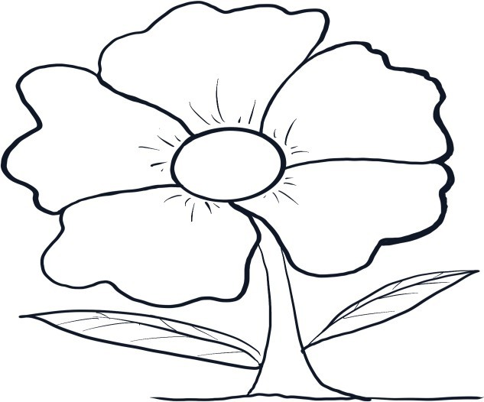

Proper season temperatures

Animals aren’t extinct nor endangered

Clean Cities

Healthy humans

Fresh air

**ACTIVITY 3**

In the box provided draw and color your dream community.

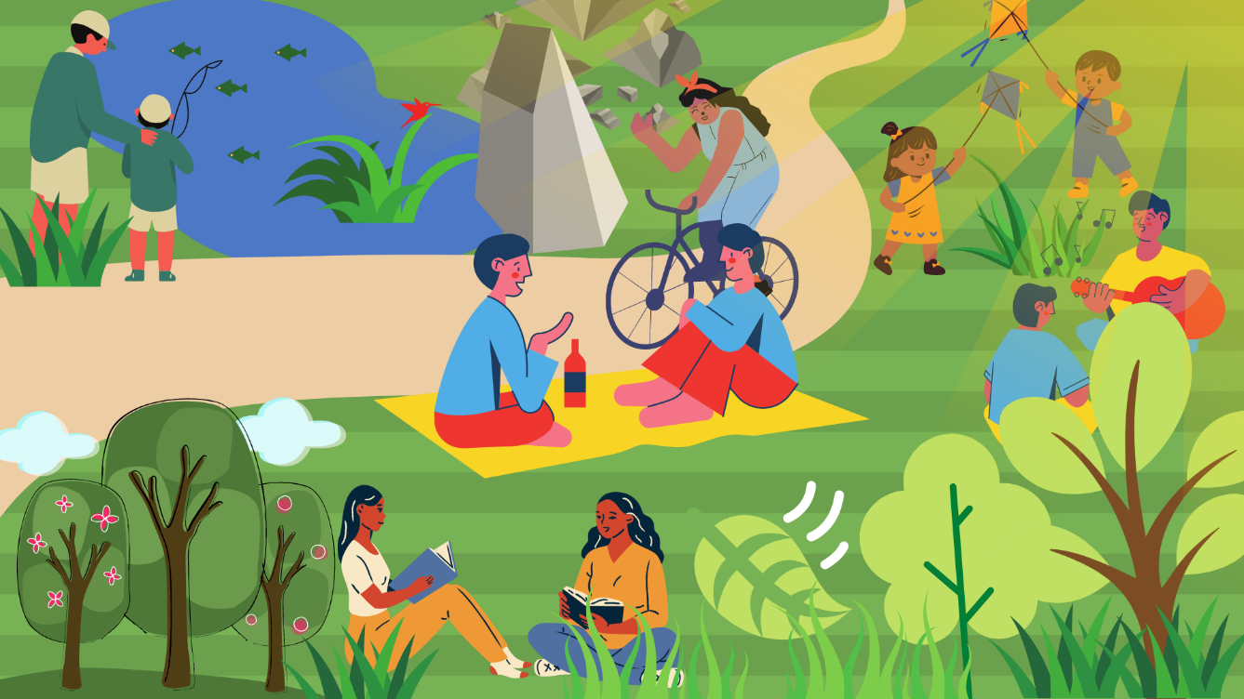

Answer the following questions:

1. Based on your drawing can you say that you have a healthy community? Explain your answer. Yes, because people have interaction and many things as such that can make their minds and physical appearance better, aside from that, animals, plants, and people are healthy and their environment as well.

What possible environmental health issues/problems that may affect your dream community? Various human activities such as deforestation and many more because they want their economy to grow faster so they get more resources that tend to have more purpose than money.

**ACTIVITY 4**

**Through a Poster, Slogan or Comics Suggest Ways to Prevent and Manage Environmental Health Issues.**

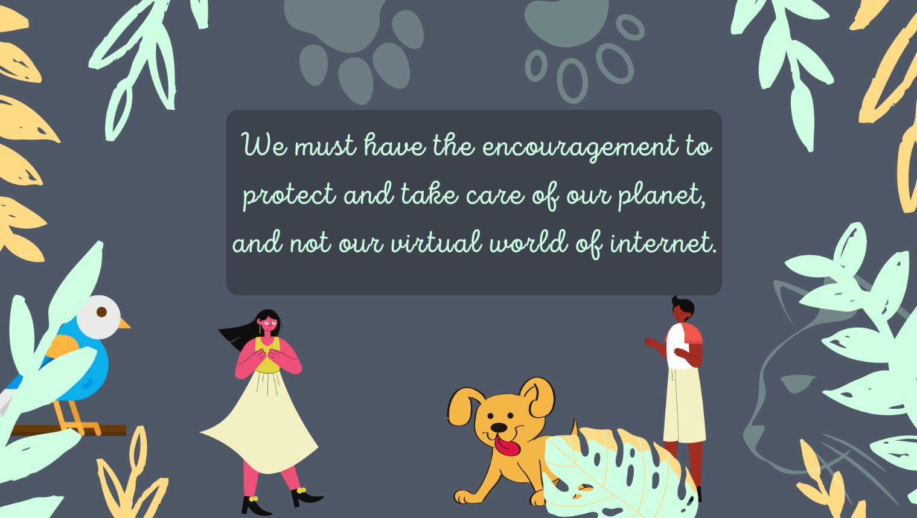

Rubric for Scoring

|  |  |  |  |  |
| --- | --- | --- | --- | --- |
| CRITERIA | EXCELLENT(4PTS) | GOOD(3PTS) | FAIR(2PTS) | POOR(1PT) |
| Content | All contents were covered and | All contents were covered. | Most of the content was covered. | Not all the contents were |
|  | students presented |  |  | covered. |
|  | the content |  |  |  |
|  | creatively. |  |  |  |
| Visual attractiveness | Format and lay-out are exceptionally attractive. | Format and lay- out are very attractive. | Format and lay-out are attractive. | Format and lay-out are not attractive. |
| Graphics and Pictures | Graphics and pictures go well with the content and information | Graphics and pictures are good but are too many that they  dominated the | Graphics and pictures are good but are too few that they dominated the material | No graphics And pictures are used. |
|  |  | material |  |  |
| Creativity | Student is creative. | Student is somewhat creative. | Students attempted to be creative. | Students are not creative. |

**REFLECTION**

SENTENCE REFLECT

1. I want to live in a clean environment by .
2. I will promote proper disposal of garbage in our household by .
3. I will maintain cleanliness in my surroundings by

**REFERENCES**

Physical Education and Health Learner’s Material, Department of Education KEY TO ANWERS

Activity 1

1. T 6. F- Noise Pollution
2. F- Return 7. T
3. T 8. T
4. F- Garbage 9. T

5. T 10. T

PREPARED BY:

ARRENPY R. MUÑOZ SAPANG BATO NATIONAL HIGH

SCHOOL

# Participates in Implementing an Environmental Project

Background Information for Learners:

This topic will give you an idea on how you will participate actively in implementing an environmental project that may solve the community problems and issues identified in your previous lesson through building your own community health action plan or projects. Community health action plans (CHAP) were defined as the written document that lists plans for achieving health improvement in the community by the Good and Health South Dakota Organization published article. Thus, it is established from the results of the respondent response in which, in this activity it refers to the generated answers in your previous lesson. In order to protect the environment to have community well you must know how to create a plan.

Generation of today are considered future leaders of the society, it is important to know how to make an action plans to protect the environment, becomes aware of the supporting agencies that could possibly extend help to your projects becomes productive and participate actively in already build and manage community environmental projects to support maintain the wellness of the community environment as Mahatma Gandhi and Alexander the Great did. Their principles serve as an inspiration to many as they lead people by example, meaning as future leaders there should be an initiative to do the task first to serve as an example among your people.

Several activities will guide you in making your own community health action projects focusing on maintaining a school or home garden or conducting a war against waste. This will require your complete participation to help save, build and maintain community wellness. It includes identifying the need priority of primary health care, elaborating the 14 agencies that support community activities and programs, a step-by- step process to create, monitor and evaluate the progress of your community health action plan.

**Learning Competency with code**: The learner participates in implementing an environmental project such as building and maintaining a school garden or conducting war on waste campaign (depends on feasibility)H9CE-Ig-h-14

**General Direction:** Read carefully the instructions given for every activity.

**1**: **Recall**… What is the lesson all about after reading the historical background above? Write your answer on the blank provided below.

**2**: **Think…**Do you think it is necessary for an individual like you to have an understanding on preparation of a Community Health Action Project? Either your answer is YES or NO explain why? Write your answer below.

**3**: **Decide to try...**The priorities among the Primary Health Care were presented in a form of star. These are activities launched by the Department of Health in promoting community health through the partnership of the community, barangay, government organization, and non- governmental organization. In order for you to build your own Community Health Action Project for implementation you must consider the following stages. The first stage is to **decide** which star catches more attention to you? Express your answer by shading the rays of the star. Less Ray shaded less attention, more shaded rays means more attention and considered as your choice.

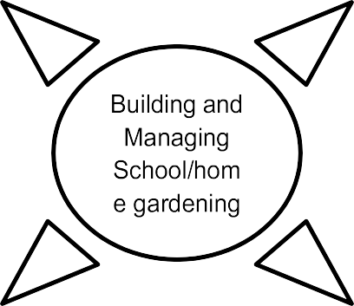

war on waste campaign

**4: Analyzing goals...**Why has it become your answer in activity no. 3? Explain and write your answer below.

**5: Must Know!**

Below are the different agencies working together for community health. Their programs are also anchored in sustaining community development. Activities and programs for the community must be coordinated to them.

Direction: The first agency was already accomplished. This time, you will define the following agencies by asking help with your classmates, friends, parents or anyone in your community who could define the remaining task.

GOVERNMENT AGENCIES SUPPORTS THE PRIMARY HEALTH CARE

|  |  |
| --- | --- |
| Agencies | Definition |
| DND | Department of National Defense |
| DepED |  |
| PIA |  |
| DBM |  |
| NEDA |  |
| PHA |  |
| DOH |  |
| PMA |  |
| PNRC |  |
| DILG |  |
| NNC |  |
| DA |  |
| PopCom |  |
| DPWH |  |

6: **EXPLORE**

Direction: Your answer is connected on what you have decided in activity 3. Answer only on your selected projects you wish to happen.

* 1. Visit or look around in your community, a place where you can make your project happen. Venue for gardening:

Venue for solid waste management:

* 1. List down the materials you needed to make your plan happen? For gardening:

For solid waste management:

* 1. Check in the box the possible ways or strategies to make your project happen?

Segregating

Planting

Digging

Posting

Tilling

Recycling

Protecting

Maintaining

Advertising

* 1. Estimate how much time and money resources will you spend on your project ways or strategies? An example for gardening first was made for you but for the war on waste should follow the same format and principle. Refer your answer in this activity to activity 6.3.

5.

|  |  |  |  |
| --- | --- | --- | --- |
| Action | Duration | Time Frame | Estimated Cost |
| Planting seeds in the can, empty  bottles, plant box, etc., | 3 Hours | 7:00 am to 11:00 am | Seed- 20 Php |
|  |  |  |  |
|  |  |  |  |
|  |  |  |  |
|  |  |  |  |

6. Write at least five (5) expected benefits of your Community Health Action Project in the community.

1. .

2. .

3. .

4. .

5. .

6. List down possible results of your Community Health

Action plan? 1. . 2. . 3. .

4. .

5. .

Activity 7. My Community Health Action Plan

As you were guided on the different activities you have made. You are asked to fill –up the box to present your own Community Health action Project for Implementation. Refer your answer on activity no.6 PART A

|  |  |  |  |  |
| --- | --- | --- | --- | --- |
| Project Title | Project Goals | Action Steps | Benefits | Output |
|  |  |  |  |  |

PART B

|  |  |  |  |  |
| --- | --- | --- | --- | --- |
| Person involve | Timeline | Resources needed | Cost | Additional  contacts |
|  |  |  |  |  |

Rubrics

|  |  |  |  |  |
| --- | --- | --- | --- | --- |
| Indicators | Excellent 4 | Very Good 3 | Good 2 | Needs Improvement 1 |
| Content | Accomplished all elements of CHAP beyond expectation | Accomplished all the boxes with appropriate information without single error . | Accomplished all the boxes with appropriate information but with slight error . | Accomplished all the box but does not have appropriate details. Need revision to  some details. |
| Clarity | Expected outputs, benefits, action steps, agencies and person involved are consistently connected to the goals and title of the project | Expected outputs, benefits, action steps, agencies and people involved are observed connected to the goals and title of the project but not all. | Expected outputs, benefits, action steps, agencies and people involved are observed connected to the goals and title of the project but not all except 2-3 elements. | Expected outputs, benefits, action steps, agencies and people involved are not observed connected to the goals and title of the project. |
| Timeliness | Submitted on time | Late for a day | Late for 2 days | Late more than 3 days |

**Reflection:** My Reflection to CHAP

**Congratulations!** You have made it. Now, you finished your community health action project. Which of the steps are difficult to accomplish? Why?

Rate your willingness to participate in the implementing environmental projects in your community as you experience participating in the building community health action plan. 5 represent the highest participation while 1 signifies the lowest participation. Encircle the number of your answer.

5 4 3 2 1

References for learners:

Doria,J.P,Gonzales,M.C.Sedilla, LJ,Capulong , J. 2014.Physical Education and Health Learning Materials.253-262.

Teacher’s Guide for P.E. and Health Grade 9.229- https://goodandhealthysd.org/wpcontent/themes/GoodAndHealthySD/communitytool kit/files/CoreProces s/Step7/GHCommunityToolKit-Step7- WritingaCommunityHealthActionPlan.pdf https://[www.mindtools.com/pages/article/newLDR_60.htm](http://www.mindtools.com/pages/article/newLDR_60.htm)

Answer Key:

Activity 1: Community Health Action Project Implementation Activity 9: Different Agencies

|  |  |
| --- | --- |
| Agencies | Definition |
| DND | Department of National Defense |
| DepED | Department of Education |
| PIA | Philippine Information Agency |
| DBM | Department of Budget and Management |
| NEDA | National Economic and Development Authority |
| PHA | Philippine Hospital Association |
| DOH | Department of Health |
| PMA | Philippine Medical Association |
| PNRC | Philippine National Red Cross |
| DILG | Department of Interior and Local Government |
| NNC | National Nutrition Council |
| DA | Department of Agriculture |
| PopCom | Population Commission |
| DPWH | Department of Public Works and Highways |

Prepared by:

LEIZEL G. SAHIBIL